- Course name: Junior Certificate Course on Surveying Technology (JCST)
Total Seats: 22. Two (02) seats are reserved for extra-ordinary meritorious students from backward classes on free ship basis.
Course Fees: 35,000 INR (total fees)
Eligibility Criteria: Secondary Examination with total aggregate of 50% and 45% for the SC/ST/OBC students.
Subjects to be covered: The entire course is elaborately divided in four semesters. Each semester will contain four (04) SCST T theory papers of 100 Marks (each) and (02) SCST P practical papers (50 marks each) except the fourth semester where the students will have to undergo dissertation/field training. The Semesters along with the papers to be taught are discussed below:
Semester I: (JCST I)
Papers taught:
JCST T 001: History Fundamentals of surveying technology
JCST T002: Land Survey by Chain & Tape
JCST T 003: Plane Table & Prismatic Compass Survey
JCST T004: Elementary mathematics & Fundamentals of Calculus, Trigonometry & Algebra
JCST P001: Chain & Tape Survey
JCST P002: Prismatic Compass & Plane Table Survey
Semester II: JCST (II)
Papers taught:
JCST T 005: Dumpty level, Auto Level & Theodolite Surveying
JCST T 006: Fundamentals of Geomorphology & Geology
JCST T 007: Elements of Business Communication, Project Management & Communicative English
JCST T 008: Elementary Statistics & Cartographic Modeling
JCST P 003: Dumpty Level, Auto level & Theodolite Surveying
JCST P 004: Elements of Map making & landform profiling
Fees Structure & process of admission: 15000 INR is to be deposited in the institute cash section during admission while the rest 10000 INR is to be deposited in two successive installments of 5,000/-each during the second and third modules.
Interested candidates are requested to collect admission form along with the detailed prospectus from the head office of Prantik Care the Earth either in person or through email or Courier services/Indian Postal services by paying a demand draft/cheque/Internet banking transaction of an amount of 50/-INR in the official account number to be provided by office.
Selection Criteria: Eligible candidates will be shortlisted on basis of merit and will be selected for the academic session through an online interview process, date of which is to be made aware to the applicants through email/telephone by the management authority.
Date of commencement of Classes: August, 2022/January, 2023
Academic Session: 2022-2023
Dimensions of Spatial sciences
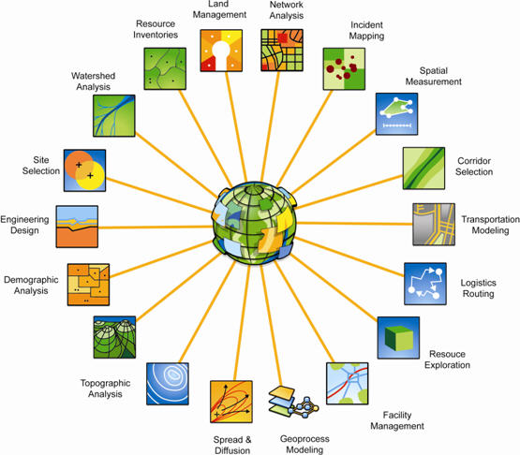
Course Name: Certificate in Surveying Technology (CCST).
Total Seats: 32. Two (02) seats are reserved for extra-ordinary meritorious students from backward classes on free ship basis.
Course Fees: 20,000 INR apart from Caution money of 5,000.00(refundable)
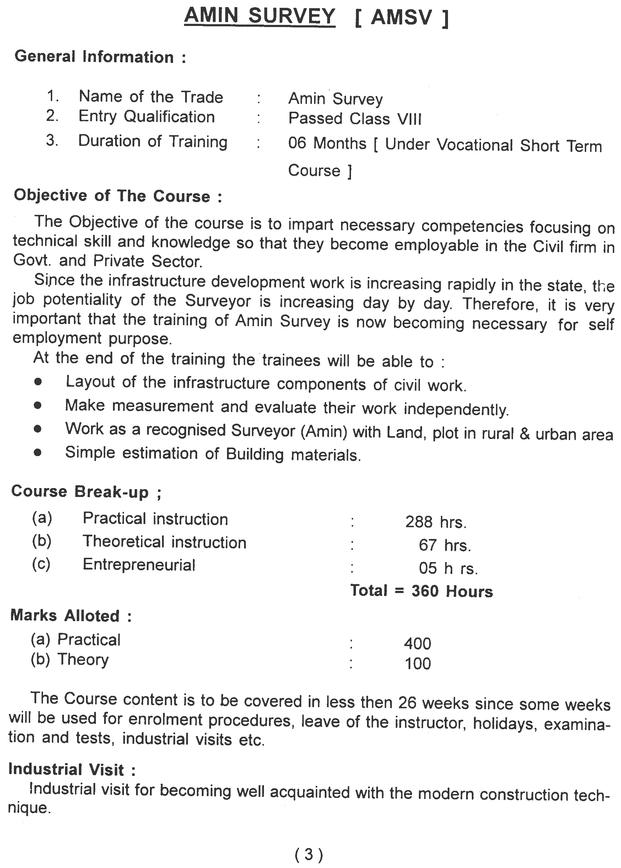
Eligibility Criteria: Higher Secondary with total aggregate of 45% and 35% for the SC/ST/OBC students/ 35% for students of Under-developed Districts.

Subjects to be covered: The entire course is to be taught in a single semester. Semester will contain five (05) CCST T theory papers of 100 Marks (each) and two (02) CCST P practical papers (50 marks each. The Semesters along with the papers to be taught are discussed below:
Semester I: (CCST I)
Papers taught:
CCST T 001: History & Fundamentals of surveying technology
CCST T002: Geocomputations (Land Survey by Chain& Tape, Prismatic Compass & Dumpy level, Theodolite, etc.)
CCST T 003: Elementary mathematics & Fundamentals of Calculus, Trigonometry, Calculus & Matrix
CCST T004: Introduction to Electronic Total Station, GPS & DGPS.
CCST T 005: Elements of Business Communication, Project Management & Communicative English
CCST P001: Geocomputations Lab
CCST P002: ETS, GPS & DGPS Lab
Fees Structure & process of admission: 20,000.00 INR is to be deposited in the institute cash section during admission along with the caution money of 5000.00, which is refundable after the successful completion of the course through proper process of application after the completion of the course.
Interested candidates are requested to collect admission form along with the detailed prospectus from the head office of Prantik Care the Earth either in person or through email or Courier services/Indian Postal services by paying a demand draft/cheque/Internet banking transaction of an amount of 50/-INR in the official account number to be provided by office.
Selection Criteria: Eligible candidates will be shortlisted on basis of merit and will be selected for the academic session through an online interview process, date of which is to be made aware to the applicants through email/telephone by the management authority.
Date of commencement of Classes: August, 2022/January, 2023
Academic Session: 2022-2023

